COVID Oximetry@home Patient Information Leaflet

Summary Page

- Your clinician has recommended you to monitor your oxygen levels. This will help monitor your COVID infection.
- You should continue to follow national advice on self isolation.
- Oxygen levels can be measured with a pain free finger sensor (oximeter)
- Use the diary to keep a record of your daily symptoms and readings. The COVID Oximetry @ home team will call you daily to check the levels you are recording.
- If you have any queries about this process, you can contact the team by calling
01626 204950. They are available 9am to 5pm Monday to Sunday.
- If oxygen levels look low, recheck the instructions to ensure correct use of equipment
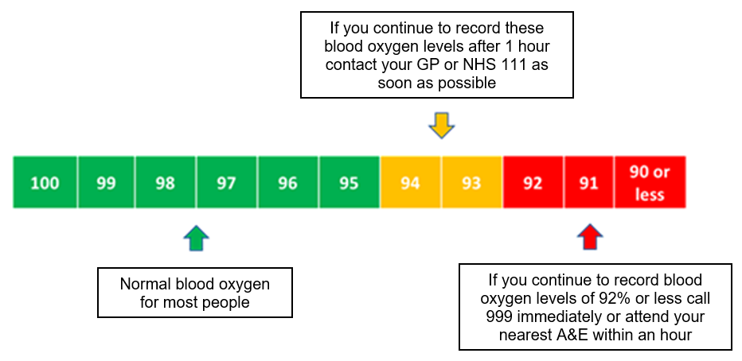
- If oxygen levels reduce follow the guide below, unless you have agreed a different target with your doctor in which case follow that advice.
- At the end of 14 days monitoring, the CO@h team will call you and support your exit from the service.

Why have I been given this leaflet?
You have been assessed and have symptoms of the COVID-19 virus and referred for COVID Oximetry@home (CO@h) so we can support you, or your carer, to monitor your condition over the next 14 days.

Please remain at home and follow the latest advice (via the NHS website – link below) for the next 10 days or until your symptoms have gone. Pay special attention to hand washing regularly and use of a face mask when around others, even in your home.

Please see the NHS website at https://www.nhs.uk/conditions/coronavirus-covid-19/

How does CO@h work and what do I need to do?
We have learnt that monitoring your blood oxygen level is the most accurate way of keeping an eye on your progress when you have symptoms of COVID-19. To do this you will be provided with a device called a pulse oximeter to take blood oxygen readings.
You will be monitoring your condition each day with our support. You will agree whether you prefer to submit your oxygen level readings to the CO@h team over the telephone or via a mobile phone app, for which instructions will be given. The CO@H team are based at the Devon Referral Support Service and will be supporting your GP Practice to monitor your symptoms over this 14 days.

The CO@H team will be able to answer any general queries you have about this process whilst you are using this service. You can contact them by calling 01626 204950. They will be available between 9am and 5pm Monday to Sunday.

You will need to monitor your symptoms each day you are using the CO@H service, after which point we will ask that you return the oximeter. If your condition has worsened or you do not feel able to safely manage your symptoms at home, you should contact your GP practice to discuss the next steps in your care. Paracetamol and regular fluids can help with mild symptoms, and most people will get better by themselves within two to three weeks.

If you do start to feel more unwell, or your symptoms worsen please refer to the tables below to help you decide who to contact.

What is a pulse oximeter?
A pulse oximeter is a medical device that, using a probe attached painlessly to a clean finger, measures your blood oxygen levels. An ideal blood oxygen level is between 95% and 99%. An ideal heart rate is between 50 and 90 beats per minute (bpm).
We would expect your oxygen saturations to be at 95% or above when sitting. If it is below 95%, check it again to ensure the oximeter reading was correct, and then again after 1 hour. If it is still below 95%, please follow the emergency advice.
The oxygen saturation may be lower in some people with chronic lung and other conditions even when they are well. The person completing your initial assessment will give you guidance in this event, when they take your ‘baseline’ or initial reading.

How to use a pulse oximeter
You can access this YouTube video which shows how to use the oximeter or follow the instructions below.
English: www.youtube.com/watch?v=nx27Ck7xOgo
Polish: www.youtube.com/watch?v=Lkd-BNeMvLs
Hindi: www.youtube.com/watch?v=e1ipiJY-zwk
Punjabi: www.youtube.com/watch?v=wU5V6wVEHoM
Urdu: www.youtube.com/watch?v=rkG

Instructions for use  Cold hands, movement, dirt on the sensor and nail varnish can produce an inaccurate reading, so please follow these instructions:  - Remove any nail polish or false nails and warm your hand if cold.  - Make sure you have been resting for at least five minutes before taking your measurement.  - Rest your hand on your chest at heart level and hold still. | 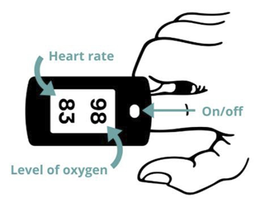  Image courtesy of Denis Barbulat
- Switch the pulse oximeter on and place it on your finger. It works best on your middle or index finger (shown in the diagram). It should not be used on your ear.
- The reading takes time to steady. Keep the pulse oximeter in place for at least a minute, or longer, until the result has not changed for five seconds.
- Record the highest result once the reading has not changed for five seconds.
- Be careful to identify which reading is your heart rate and which is your oxygen level.
- Remove the device. It will turn off automatically.

Recording the results from the pulse oximeter
The first time you use the pulse oximeter, you will have your baseline reading which you need to add into the highlighted area of the diary. Once you have recorded this you should take following readings at the same time each day – for example when you normally eat in the morning, at lunchtime and in the evening. Please also record changes in how you are feeling and your breathing.
Please also take your temperature if you have access to a thermometer. However, as long as your oxygen level and breathing are normal, you do not need to contact your GP/NHS 111 if you have a temperature or other symptoms, such as cough, muscle aches, tiredness and change in taste or smell. Paracetamol and regular fluids can help with these symptoms, and most people will get better by themselves within two to three weeks. Please see the NHS website for information on self-isolation or how to access care.
Record all readings in the diary.

You will need to monitor your symptoms and oxygen levels for 14 days from the onset of your symptoms.
What should I do if my symptoms get worse?

You should attend A&E as quickly as possible or call 999 immediately if you experience the following:

- Your blood oxygen levels are 92% or less OR 5% lower than your usual level
- You are unable to complete short sentences when at rest due to breathlessness
- Your breathing gets worse suddenly
OR If you develop these more general signs of serious illness, for example:
- You cough up blood
- Feel cold and sweaty with pale or blotchy skin
- Develop a rash that does not fade when you roll a glass over it
- Collapse or faint
- Become agitated, confused or very drowsy
- Stop passing urine or are passing much less than usual
You should tell the operator you might have coronavirus if you have not had a positive test result. A minority of people with COVID-19 will experience these more severe symptoms. These require urgent medical attention.

Ring your GP Practice or NHS 111 as soon as possible if you experience any new or an increase in any the following COVID-19 symptoms:
• Feeling breathless or difficulty breathing, especially when standing up or moving
• Severe muscle aches or tiredness
• Shakes or shivers
• If you use a pulse oximeter and your blood oxygen levels is 94%, 93% OR are 3-4% lower than your usual reading after a re-test one hour later.
• Sense that something is wrong (general weakness, severe tiredness, loss of appetite, peeing much less than normal, unable to care for yourself – simple tasks like washing and dressing or making food).

You should tell the operator you might have coronavirus if you have not yet had a positive test result.

•

Family and friends checking you are safe
It is important that someone checks on you regularly. If you are isolating from other people in the same house as you, talking on your phone or through a doorway could be better than sending text messages. It will help them hear if you are becoming more breathless or unwell.
If you live alone, you should arrange to contact someone regularly. Ask them to ring you if you don’t contact them as planned and ask them to seek help if you don’t answer.
If you are still unwell after your time in the CO@H service, please contact your GP.
Returning the pulse oximeter
We only have a limited number of pulse oximeters to loan out and each one is marked with a unique serial number so we are able to track their return. When you no longer need it, it will be safely cleaned and given to other patients. Please:
- wash your hands with soap and water
- clean the pulse oximeter with an antibacterial wipe
- put in a clean bag clearly marked with your name and address. . A zip-lock or freezer bag, or a sealed envelope will suffice
- return it as directed by the CO@h team

Frequently asked questions

- How long will I be using my oximeter ?
You will use the oximeter to take daily readings for 14 days from the onset of your symptoms.
- What happens if I exit the service and become worried about having symptoms of coronavirus?
If you develop new symptoms after getting better, depending on the symptoms you are experiencing, you should follow the advice above and contact either your GP Practice or NHS 111 or 999.
- Can I use my own pulse oximeter?
Yes, provided it has a CE kite mark. However, please do not use a smartphone or smartwatch as oximeters because these have not yet been fully proven as an accurate monitor.
- What should I do if I have any problems using my pulse oximeter?
If the problem arises during the day, do mention this when the team call you to take your readings. If you are using the app to log your readings, you can still call the team for any practical questions about using the oximeter by phoning 01626 204950. They can organise a replacement monitor if needed.
If the monitor is not working outside of the team’s working hours and you feel unwell, please contact 111 for advice.

Remote monitoring COVID-19 Diary
First name ________________________ Surname _________________________
Date of birth ______________________ Age ________ NHS number___________________

Live alone Carer at home
Please record these three times a day
Days since first symptoms  _______ |  |  | Date | Pulse | Oxygen level (%) | Temper-  ature | Feeling: better/same  /worse | Breathing: better/same  /worse
Day | Time | Reading
Baseline reading:
 |  | 1st
 |  | 2nd
 |  | 3rd
 |  | 1st
 |  | 2nd
 |  | 3rd
 |  | 1st
 |  | 2nd
 |  | 3rd
 |  | 1st
 |  | 2nd
 |  | 3rd
 |  | 1st
 |  | 2nd
 |  | 3rd
 |  | 1st
 |  | 2nd
 |  | 3rd
 |  | 1st
 |  | 2nd
 |  | 3rd
 |  | 1st
 |  | 2nd
 |  | 3rd
 |  | 1st
 |  | 2nd
 |  | 3rd
 |  | 1st
 |  | 2nd
 |  | 3rd
 |  | 1st
 |  | 2nd
 |  | 3rd
 |  | 1st
 |  | 2nd
 |  | 3rd
 |  | 1st
 |  | 2nd
 |  | 3rd
 |  | 1st
 |  | 2nd
 |  | 3rd

